Handout no. 4

|  |  |
| --- | --- |
| **Name** | M.Umar Saleem,M.Usama,  Abdul jabbar |
| **Reg. No** | 2019-EE-356,366,376 |
| **Marks/Grade** |  |

**EXPERIMENT # 4**

**Error Correction of Single-Phase Current transformers**

**Objective:**

At the end of this lab session students will be able to

* Use De Lorenzo power system Protection kits.
* Implement “Current transformer” by using De Lorenzo power system Protection kits.
* Current Transformer operation in an electrical subsystem.

**Introduction:**

Utilities are responsible for the generation, transmission and distribution of electricity to customers. Part of this responsibility is ensuring a safe but yet reliable power supply to customers. For the purpose of safety and protecting the transmission and distribution network from faults, utilities worldwide have sophisticated protective equipment. Collectively, these are known as secondary equipment and include the current transformers (CT), potential transformer (PT) and protective relays.

**Apparatus:**

* 1DL 1017R Resistive Load
* 1DL 1055TT Experimentation Transformer
* 1DL 2108T10 CT LOAD
* 1DL 2109T21 Single Phase Current Transformer
* 2 DL 2109T5A Moving Iron Ammeter (5A)

**Current Transformers:**

The basic principle of the current transformer is the same as that of the power transformer. Like the power transformer, the current transformer also contains a primary and a secondary winding. Whenever an alternating current flow through the primary winding, alternating magnetic flux is produced, which then induces alternating current in the secondary winding. In the case of current transformers, the load impedance or “burden” is very small. Therefore, the current transformer operates under short circuit conditions. Also, the current in the secondary winding does not depend on load impedance but instead depends on the current flowing in the primary winding.

The current transformer basically consists of an iron core upon which primary and secondary windings are wound. The primary winding of the transformer is connected in series with the load and carries the actual current flowing to the load, while the secondary winding is connected to a measuring device or a relay. The number of secondary turns is proportional to the current flowing through the primary; i.e., the larger the magnitude of current flowing through the primary, more the number of secondary turns.

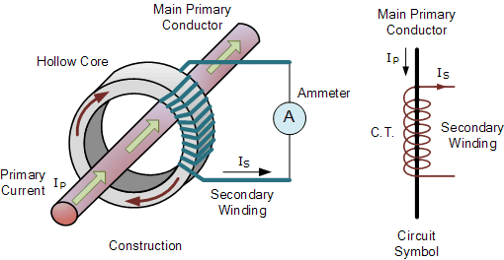

Figure 1 Working diagram of CT

The primary and secondary windings are galvanically separated and can be on a different potential level. The transformation ratio k of a current transformer is the number of secondary turns **Ns** to the number of primary turns **Np** and is equal to the primary current **Ip** over the secondary current **Is**.

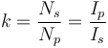

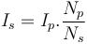

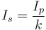

The ratio of primary current to the secondary current is known as the current transformation ratio of the CT. Usually the current transformation ratio of the CT is high. Normally the secondary ratings are of the order 5 A, 1 A, 0.1 A, whereas the primary ratings vary from 10 A to 3000 A or more.

The CT handles much less power. Rated burden can be defined as the product of current and voltage at the secondary side of the CT. It is measured in volt ampere (VA). Current Transformers (CT) are used for current metering and protection in high voltage network systems. They transform the high current on the high voltage side into low current (1 or 5 A) adequate to be processed in measuring and protection instruments (secondary equipment, such as relays and recorders). A current transformer also isolates the measuring instruments from the high voltage of the monitored circuit. Current transformers are commonly used for metering and protection in the electrical power industry.

***Circuit construction:***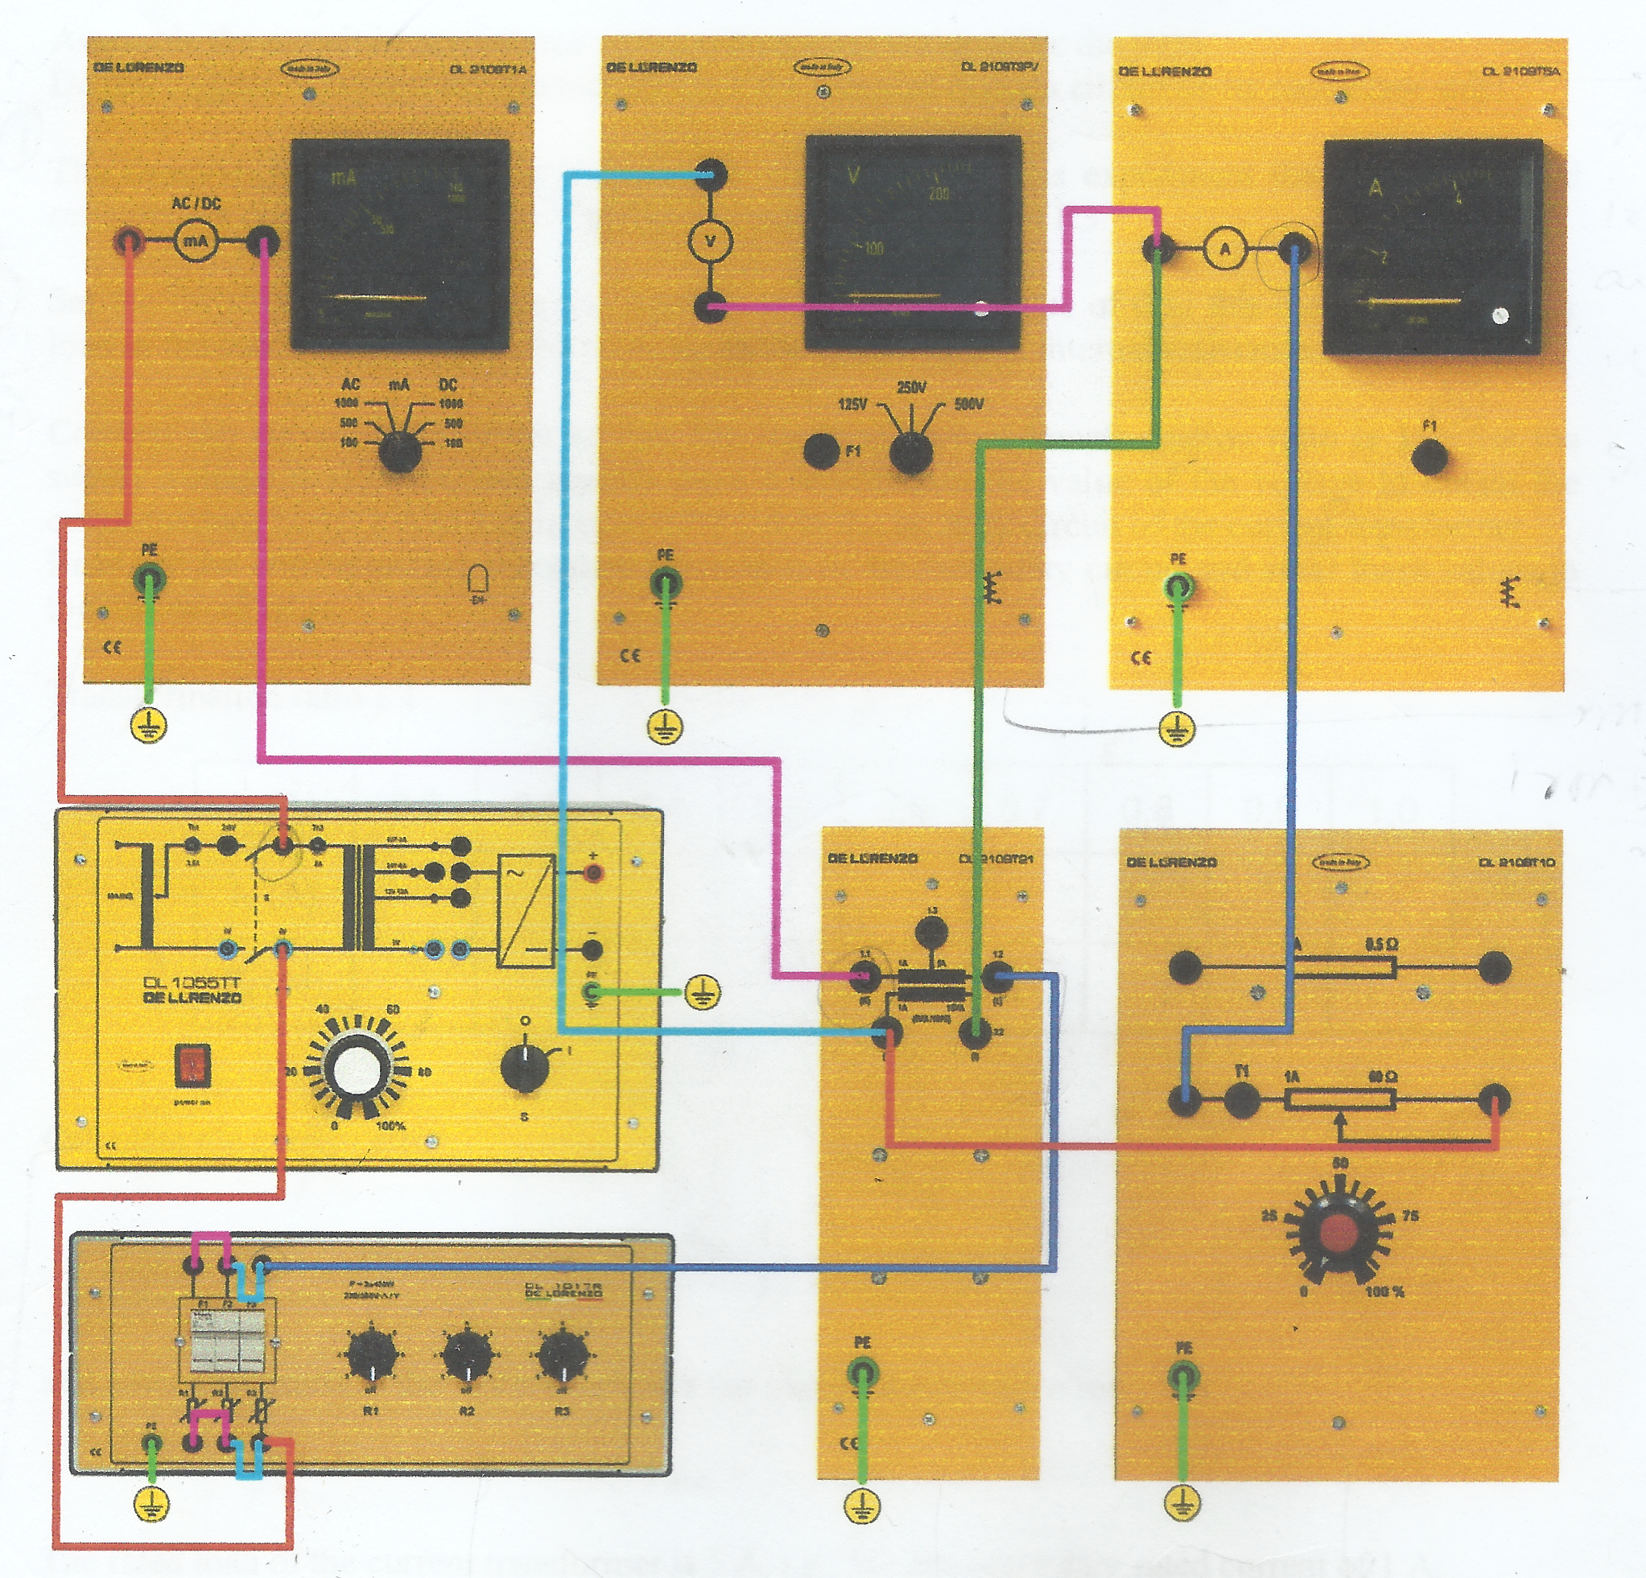

Figure 2 Current T/F circuit

**Procedure:**

* Connect circuit as shown in Fig 2.
* The resistive elements should be connected in parallel.
* Set resistive loads of CT on secondary side to an initial value of 0%.
* Connect current transformer so that resulting current ratio is 1:1
* Set power supply voltage 0÷250v and increase value of primary voltage so that current increases from 0A to 1A in step of 0.1A in primary of current transformer
* Same procedure will be done for current ratio 5:1.

**Transformation ratio1:1**

In this table 1 I have selected different primary current values for setting of 1:1 CT ratio and measured corresponding secondary values and noted in Table given below.

**Table 1: Primary and Secondary current Values at different setting**

|  |  |  |  |  |
| --- | --- | --- | --- | --- |
| Voltage (V) | 59.1 | 71.5 | 77.7 | 85.1 |
| I1(mA) | 500 | 600 | 650 | 700 |
| I2(mA) | 500 | 600 | 650 | 700 |
| Fi(%) | 0 | 0 | 0 | 0 |

**Calculate current error**:

**Fi = (KN.I2-I1/I1)*100%**

In table 2 I have fixed voltage level corresponding to primary current, by fixing one primary value, Burden is varied from 0% to 100%, and secondary value is calculated and noted in table give below.

**Table 2: Primary and Secondary current Values at different Load Values**

|  |  |  |  |  |  |
| --- | --- | --- | --- | --- | --- |
| Load | 0% | 25% | 50% | 75% | 100% |
| I1(mA) | 500 | 500 | 500 | 500 | 500 |
| I2(mA) | 500 | 420 | 350 | 250 | 200 |
| Fi(%) | 0 | 16% | 30% | 50% | 60% |

**Transformation ratio 5:1**

In this table 1 I have selected different primary current values for setting of 5:1 CT ratio and measured corresponding secondary values and noted in Table given below.

**Table 3: Primary and Secondary current Values at different setting**

|  |  |  |  |  |  |
| --- | --- | --- | --- | --- | --- |
| Voltage (V) | 60.4 | 72.9 | 78.9 | 85.5 | 97.8 |
| I1(mA) | 500 | 600 | 650 | 700 | 800 |
| I2(mA) | 100 | 120 | 140 | 150 | 155 |
| Fi(%) | 0 | 0 | 7.69 | 7.14 | 3.12 |

**Calculate current error**:

**Fi = (KN.I2-I1/I1)*100%**

In table 2 I have fixed voltage level corresponding to primary current, by fixing one primary value, Burden is varied from 0% to 100%, and secondary value is calculated and noted in table give below.

**Table 4: Primary and Secondary current Values at different Load Values**

|  |  |  |  |  |  |
| --- | --- | --- | --- | --- | --- |
| Load | 0% | 25% | 50% | 75% | 100% |
| I1(mA) | 800 | 800 | 800 | 800 | 800 |
| I2(mA) | 160 | 155 | 150 | 148 | 145 |
| Fi(%) | 0 | 3.12 | 6.25 | 7.5 | 9.37 |

**Conclusion and Discussion:**

We learnt about the use of De Lorenzo power system Protection kits.

We have implemented “Current transformer” by using De Lorenzo power system Protection kits and observed the results.

In this lab we have learnt about the error correction of single-phase current transformer. First, we implemented the single-phase transformer of 1:1. We design this circuit on hardware power system setup. We vary the different value of current by using the variable power supply. We observed their properties and variation in their value by hardware.

We have also learnt the application of Current transformer such as Current Transformer operation in an electrical subsystem.

We also observed that the basic principle of the current transformer is the same as that of the power transformer but the difference we learnt in this session was that in the case of current transformers, the load impedance or “burden” is very small. Therefore, the current transformer operates under short circuit conditions. We have learnt and observed from results that the current in the secondary winding does not depend on load impedance but instead depends on the current flowing in the primary winding.